SYNOPYSIS

PRESENTING A WELL DEFINED MODULES OF PROJECT

Referred To : Enroll No:
Training Head Student Name :
Rahul Soni College Name :
--------------------------------------------------------------------------------------------- SYNOPYSIS OF URBANCLAP

Description Of Project:

UrbanClap is a leading platform dedicated to making home services hassle-free and accessible. Whether you're looking for a professional to handle a quick repair, a skilled beautician for a home salon experience, or a reliable cleaner for your space, UrbanClap connects you with experts who meet your needs.

Aim of Project
- Wide Range of Services: From plumbing and electrical repairs to beauty treatments, cleaning, and more, UrbanClap offers a comprehensive list of services tailored to your home and personal needs.
- Verified Professionals: All service providers are carefully vetted and trained to ensure high-quality work and reliability.
- Easy Booking: Schedule your services through a user-friendly app or website interface, and choose a time that fits your convenience.
- Transparent Pricing: Clear and upfront pricing with no hidden fees ensures you know exactly what to expect.
- Customer Reviews: Read real reviews from other users to make informed decisions about the service providers.

Decided Zones For Project
UrbanClap
1. General Zone
2. Admin Zone

Project Slot – 1 (Working with General Zone)
General Zone

Logout
Home

;
Booking History
Registration
Login
FAQs
Book Service
About us

HomePage:-

- Header & Menu:-

(Designing of General Zone’s Home Page)
- Menu & Sliders:-
Sample design of menu & Slider:-

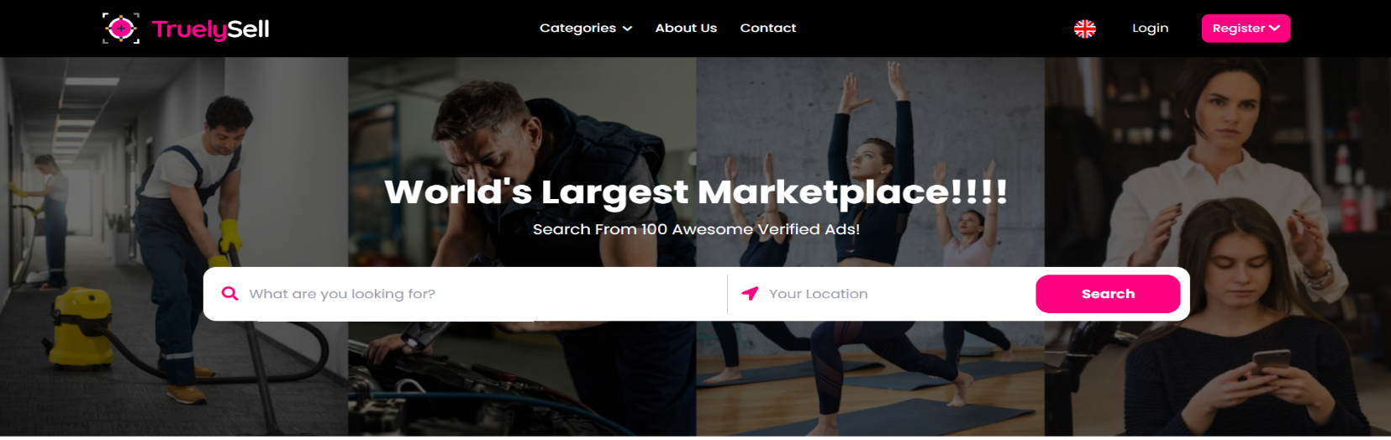

- Category:-

- Carpentry
- Plumbing
- Construction
- Electrical
- Cleaning
- Car wash
- Interior
- Computer
- Saloon
- Yoga
- Car Mechanic
- Spa
- Beauty & Personal Care
- Cleaning
- Baby Setting
- Home Services
- Repair Services

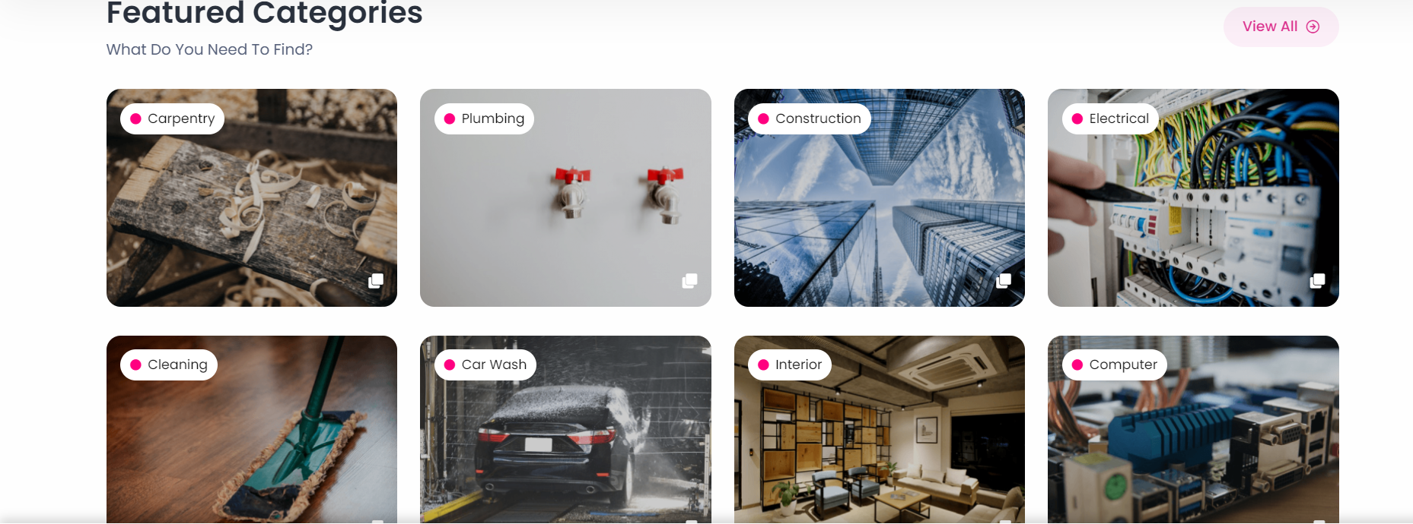

- Latest Services

- Air condition service:-
- Wooden carpentry service:-
- Plumbing service:-

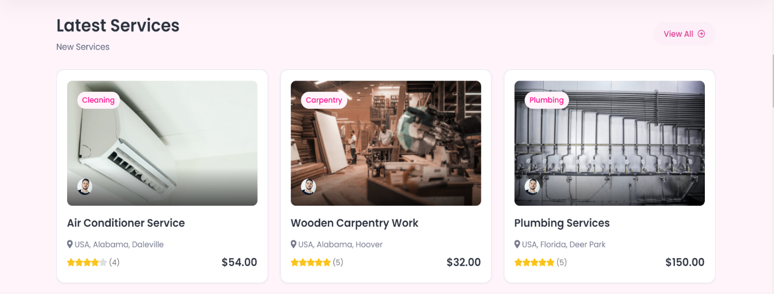

- Most Popular Service

- Car Repair Service
- Glass Fitting Service
- Computer & Server AMC Service

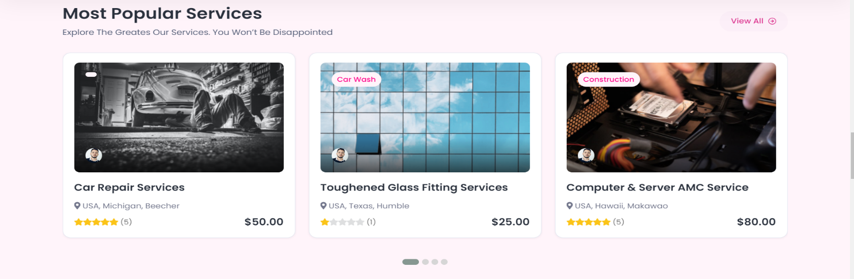
- Footer
- Categories
- Quick links
- Contact us
- Social links
- **Copyright & Develop By (Mandatory)

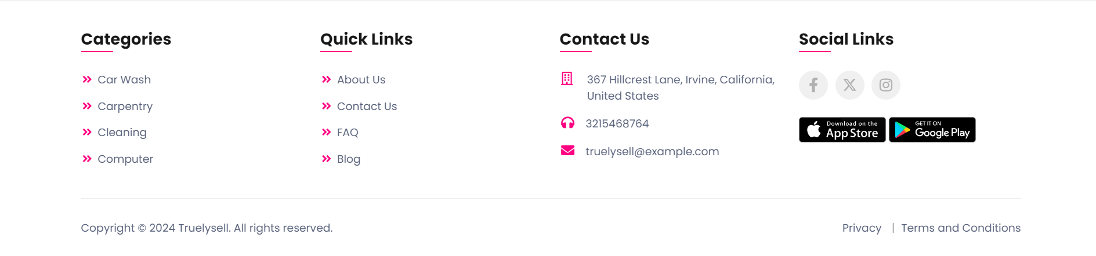
Project Day 3 : (Designing of General Zone’s Contact Us , About Us Page & Jobs Page)

Contact us page will contain :

- Name, Contact no, Messages:
Sample of Contact us page:-

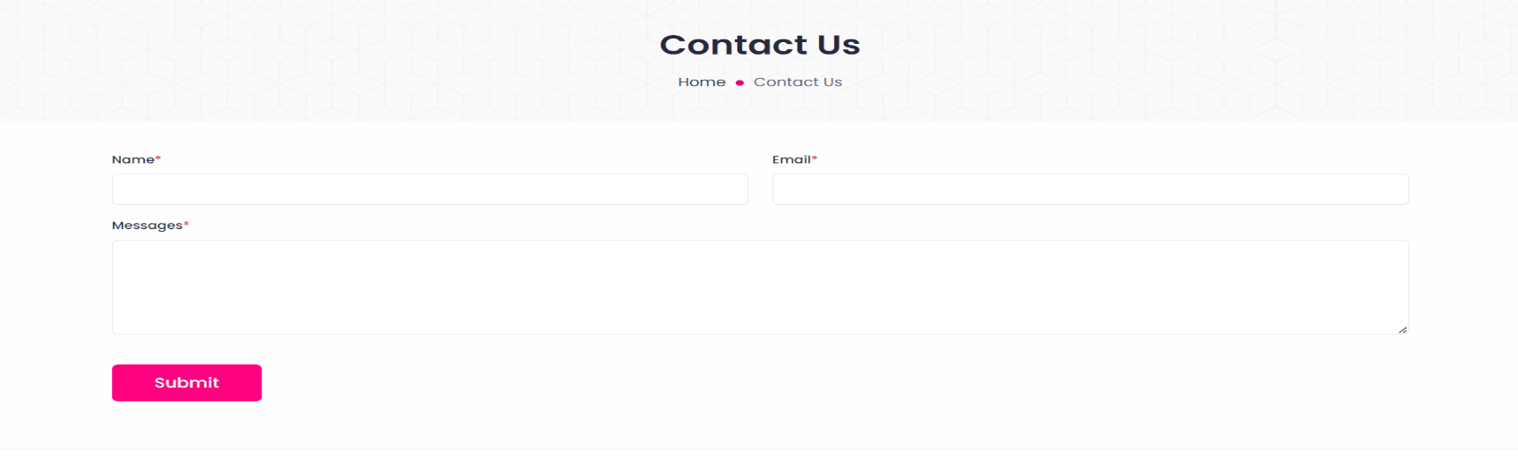

- About us page :-
Sample of about us page—

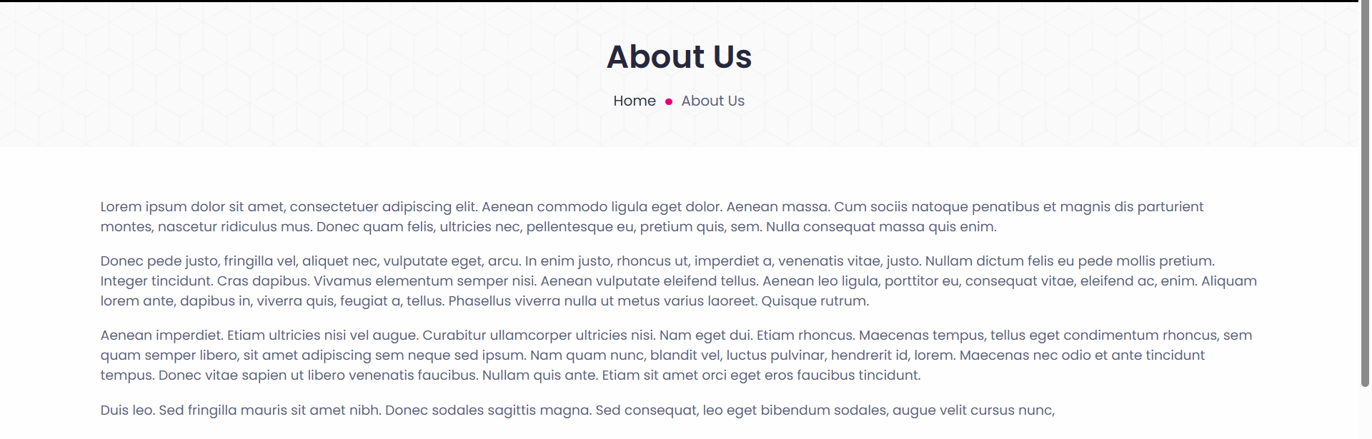

Content of About Us-
UrbanClap is your go-to solution for seamless and reliable home services. Our platform is designed to connect you with top-notch professionals who can handle a diverse range of tasks, from urgent repairs and routine maintenance to beauty treatments and thorough cleaning.

At UrbanClap, we understand the importance of having trustworthy and skilled experts in your home. That's why we meticulously vet and train all our service providers to ensure that they deliver exceptional quality and reliability. Our user-friendly app and website make booking services a breeze, allowing you to select a time that fits your schedule with just a few taps.

We pride ourselves on transparency, offering clear and upfront pricing with no hidden fees, so you know exactly what to expect. Plus, our customer review system provides genuine feedback from other users, helping you make informed decisions and choose the best professional for your needs.

Experience the convenience and peace of mind that comes with UrbanClap—where quality service meets effortless accessibility.

Project Day 4 : (Designing of General Zone’s Category page)
Category page is dynamic page where all category will be displayed on the basis of filters. Admin will add Category and Service providers details. 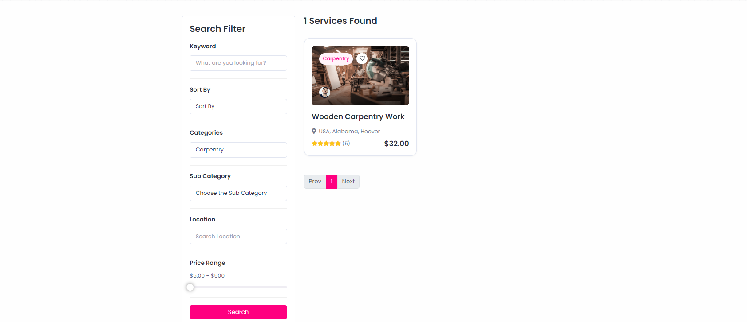

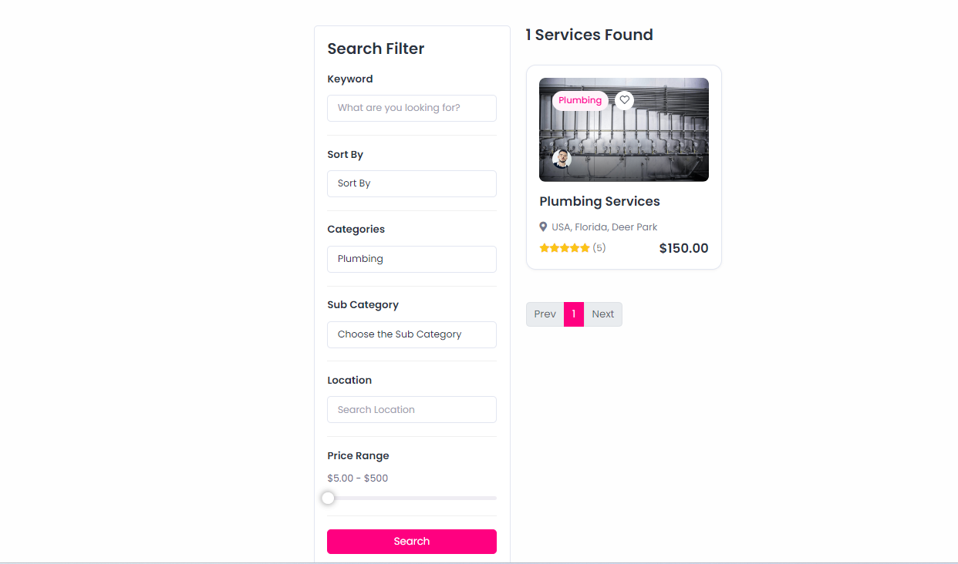

FAQs:-

Adding a FAQs page for details about UrbanClap:-

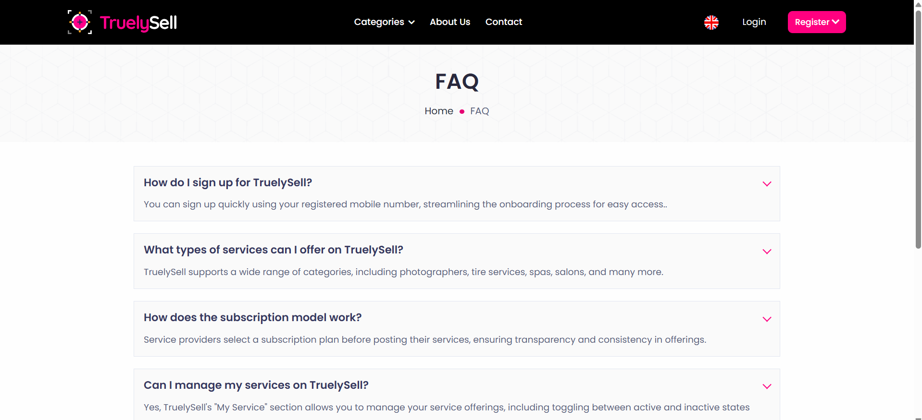

Content of FAQs:-

1. What is UrbanClap?

UrbanClap is a platform that connects users with a wide range of home service professionals, including repair technicians, beauticians, and cleaners, making it easy to book reliable services for your home and personal needs.

2. What types of services does UrbanClap offer?

UrbanClap offers a comprehensive list of services, including plumbing, electrical repairs, beauty treatments, cleaning,Fitness & Wellness , and more.

3. How do I book a service on UrbanClap?

You can book a service through our user-friendly app or website by selecting the service you need, choosing a professional, and scheduling a time that suits your convenience.

4. Are the service providers on UrbanClap verified?

Yes, all service providers on UrbanClap are carefully vetted and trained to ensure they deliver high-quality work and reliability.

5. What if I am not satisfied with the service I received?

If you’re not satisfied with the service, please contact our customer support team. We offer a satisfaction guarantee and will work to resolve any issues or provide a refund if necessary.

6. How does UrbanClap ensure transparent pricing?

UrbanClap offers clear and upfront pricing with no hidden fees. The cost of services is communicated to you before you confirm your booking.

7. Can I read reviews about the service providers?

Yes, UrbanClap features genuine reviews from other users to help you make informed decisions about which service provider to choose.

8. Are there any additional charges for booking through UrbanClap?

No, UrbanClap charges no additional fees beyond the quoted price for the service. All costs are clearly outlined before you finalize your booking.

9. Can I choose a specific service provider?

Yes, you can select a specific service provider based on their profile, ratings, and reviews available on the platform.

10. Are there any ongoing promotions or discounts available?

UrbanClap may offer promotions and discounts from time to time. Check our app or website for the latest offers and deals.

Project Day 5 : (Designing & Coding of Admin Login & User login and Signin)

- Login page will design with the following fields :

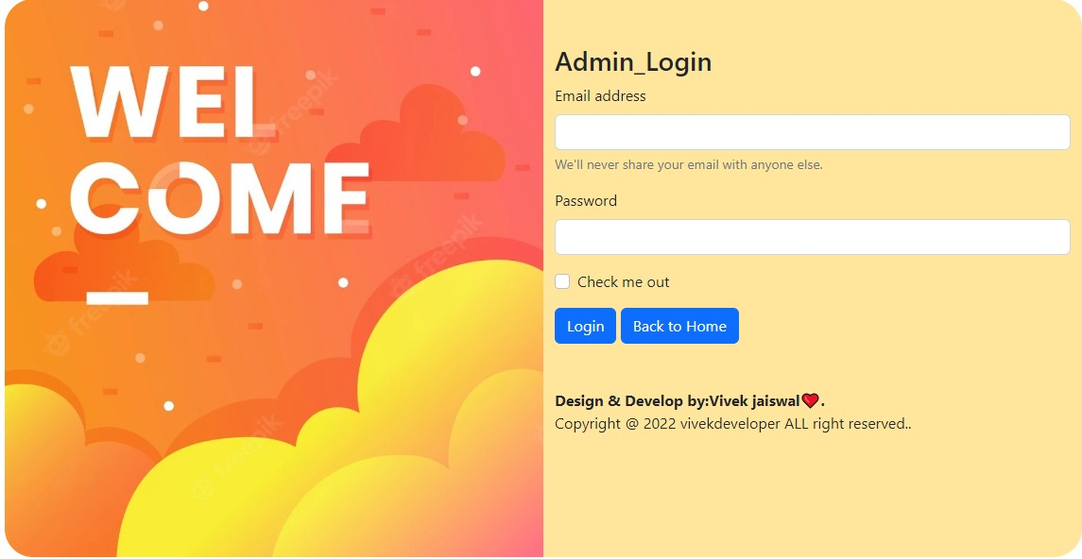

Now a prepared design of Login Page is present, further you have to code for Login so that a authorised admin can login and enter in the Admin Zone of Project.

Sample design of User SignUp page:-
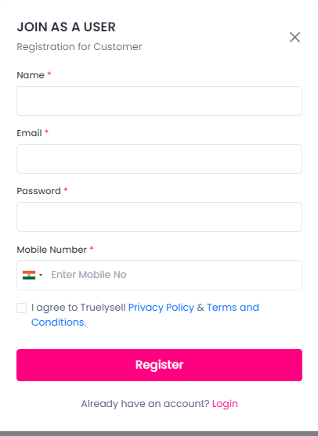
Sample design of User Login page:-
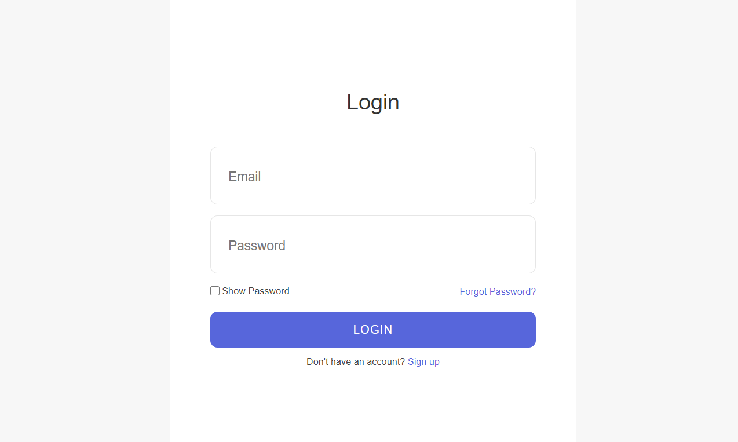
Now a prepared design of Login Page is present, further you have to code for Login so that a authorised User can login and enter in the User Zone of Project.
Project Slot – 2 (Working with Admin Zone)

Admin Zone
1.Dashboard
5.Add Images
6. Login
7. Contact Us
8. Sign up
2. Add Service
3. Add Provider

9.Booking

10.Logout

Project Day 6 : (Designing Of Master Page & Dashboard of Admin Zone)
Master page for Admin Zone will be designed that will contain some common part of all pages of Admin Zone that may be header(containing logo and menus discussed above) and footer.
Dashboard of Admin zone is a static page containing a well displayed menu of Admin Zone with the active hyperlink to related pages. You can use some special effects and animation to make it more interactive.

Sample of User Dashboard:--

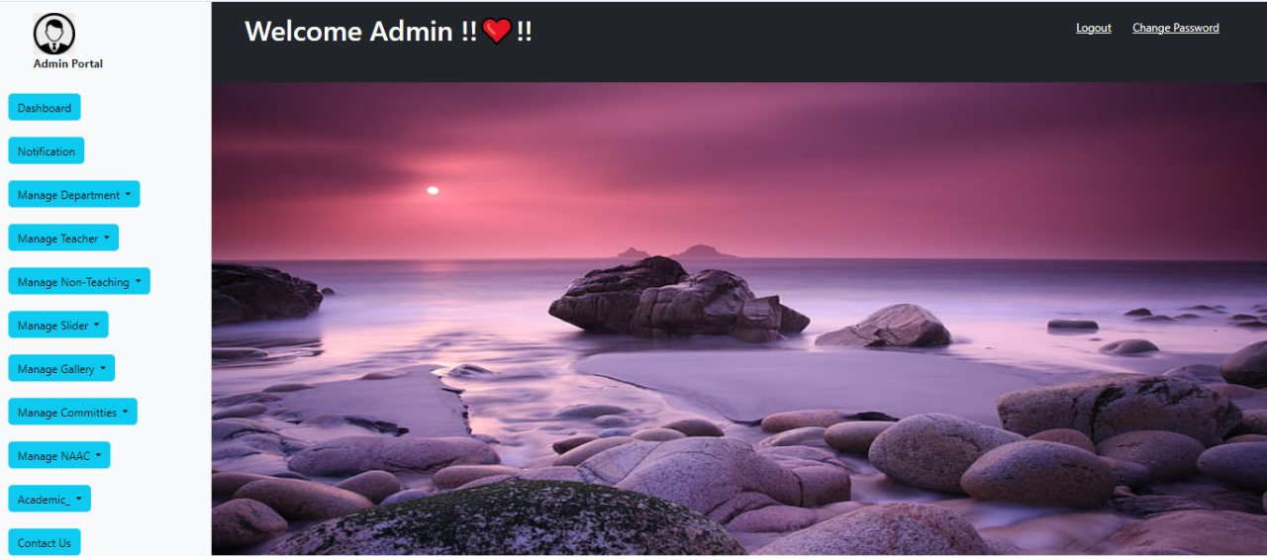

Project Day 7 : (Designing and coding of Add Category & Add Services)
Add category is a page to add new category & this will be dynamically add through all your project in a DropDownList. Here a textbox of Add Category will display & this will be saved in database.

Add Services is a page to add Service of service provider . This will contain following fields :
- Category Type (Textbox)

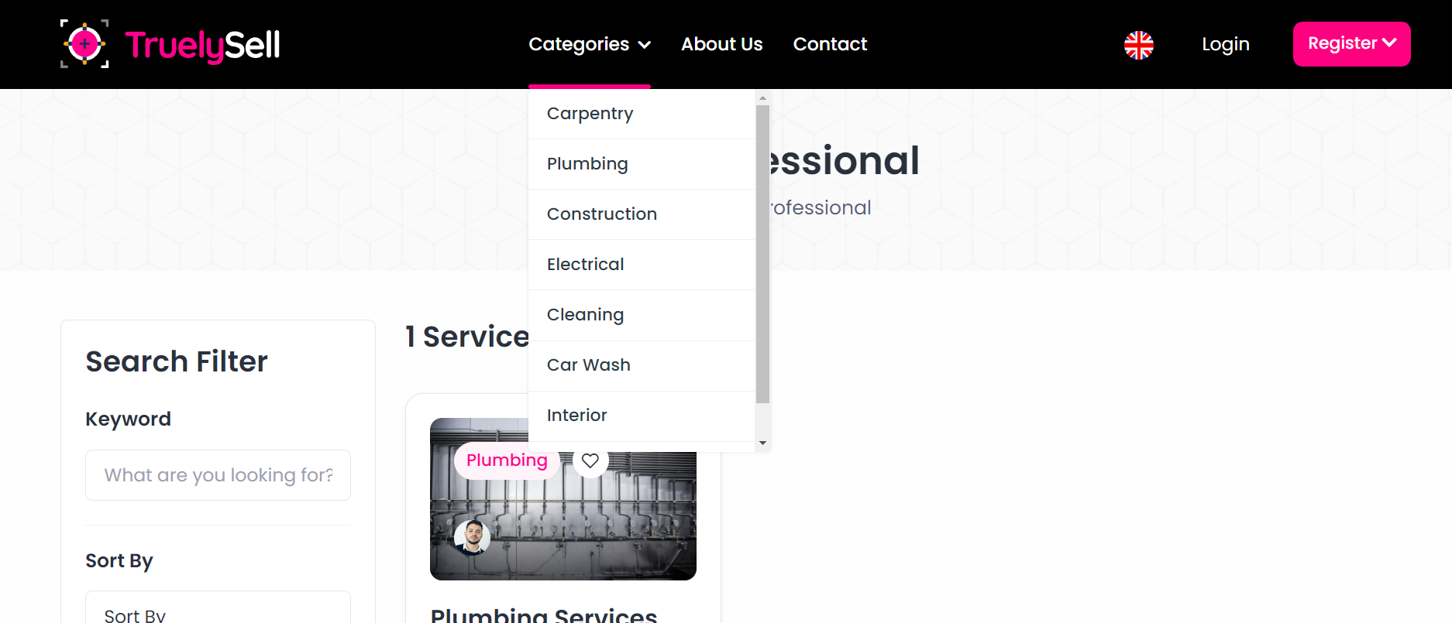
- Service providers details:-
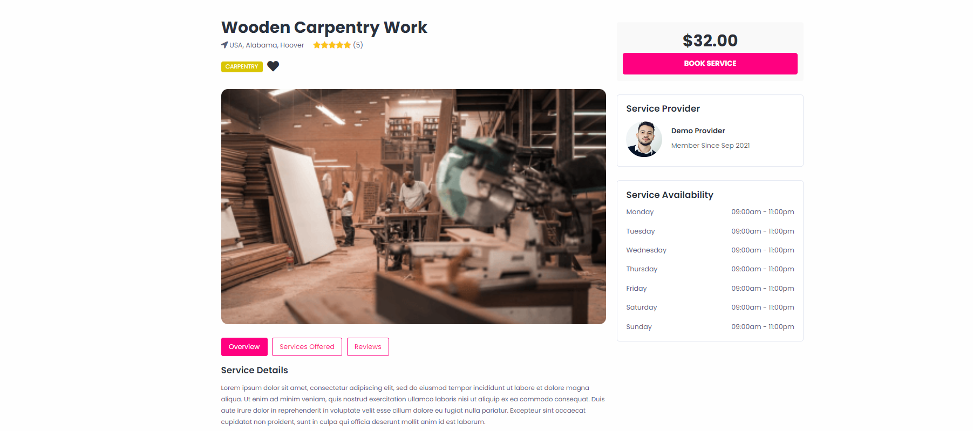

Latest Service is a page, from here admin will add Latest Service and save in database, this will dynamically show on home page.
- Headline(Textbox)
- Description(Textarea)
- Image(Fileupload)

Project Day 8 : (Designing & Coding of Add images)
Add images is page from here admin can add images that will show in the general zone’s category menu page. Here following option will display :

- Image Description (Textbox)
- Add Image (img Tag)

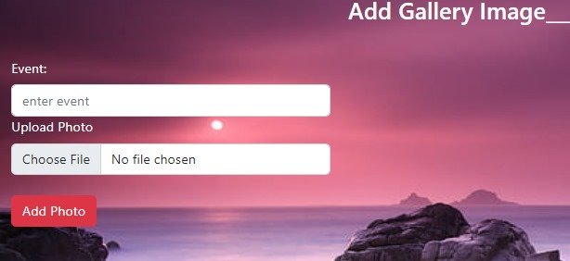

Project Day 9 : (Working with Contact Us Management)
All enquiries done with the end of user will display on this page in a tabular form.

Sample of Data..

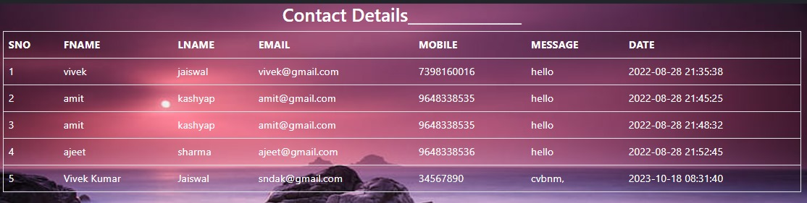

Project Day 10 :(Logout,Login )
Logout page will destroy the created session at the time of login in Admin Zone and redirect at login page.`

